CONTACTING NHP:
9-1-1 WILL ALWAYS ENSURE YOU ARE TRANSFERRED TO THE APPROPRIATE AGENCY

Knowing exactly where you are at all times is safer FOR YOU and makes reporting significant emergencies easier, ensuring the quickest, most accurate response by emergency personnel.

QUICK REFERENCE TO KNOWING YOUR HIGHWAYS

Major freeways you will encounter while travelling in Las Vegas:

I-15: Runs north and south. It is the only freeway which runs parallel to the strip. I-15 is the main freeway from California. In Nevada, it runs only through Clark County.

I-215: Runs east and west from Henderson to south Durango, then curves to run north and south to north Durango curving once again to run east and west to Aliante; this freeway is commonly referred to as “The Beltway”.

US-93: Runs north and south crossing through Boulder City to the Hoover Dam.

US-95: Runs north and south from Laughlin, NV to Mount Charleston.

SR-160: Runs north and south. It is the main highway to Pahrump, NV.

SR-159: Runs east and west. It is also known as Charleston Blvd. This is the main road to Red Rock State Park.

(PLACE AN EASY TO READ MAP WITH THESE ROUTES COLOR COORDINATION AND HIGHLIGHTED)
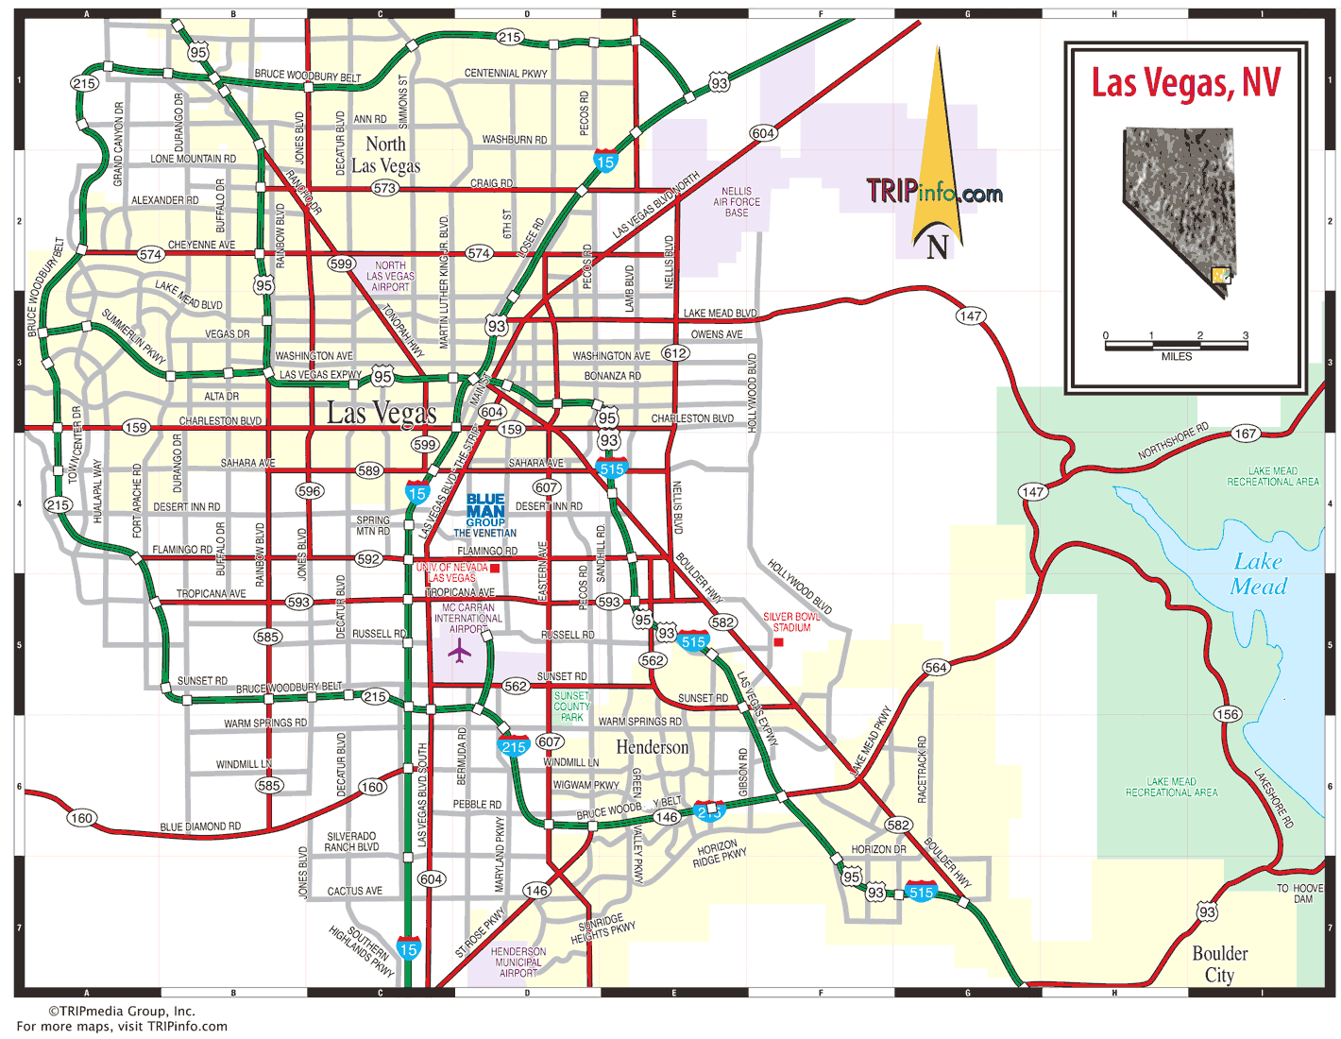

Definitions:

TRAVEL LANE: A traffic lane or travel lane is a lane for the movement of vehicles traveling from one destination to another, not including shoulders.
A shoulder, often serving as an emergency stopping lane, is a reserved lane by the edge of a road or motorway. Many wider U.S. freeways have shoulders on both sides of each directional carriageway, in the median as well as at the outer edges of the road, for additional safety. Typically the shoulder is not for use by moving traffic.
Shoulders have multiple uses, including:
- In the event of an emergency or breakdown, a motorist can pull into the shoulder to get out of the flow of traffic and obtain a greater degree of safety.
- Emergency vehicles such as ambulances and police cars may use the shoulder to bypass traffic congestion.
- It is always illegal to use shoulders for passing.

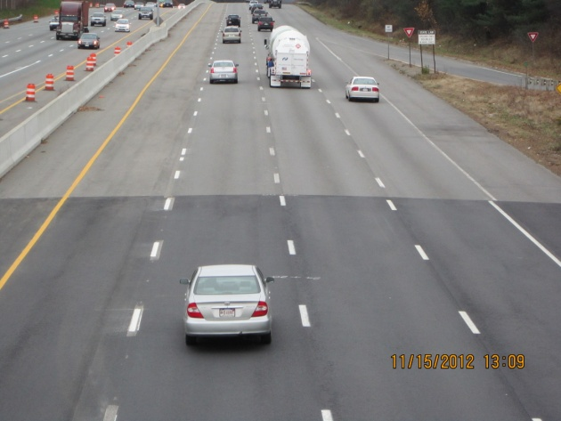

MILEMARKER: these can look differently from county to county and state to state. They are posted every mile on all major highways. In Las Vegas and surrounding areas they are typically white with black letters or green with white letters. Make sure to pay attention to the alphabetic characters listed under the number denoting which county you are in. EXAMPLE: CL=Clark

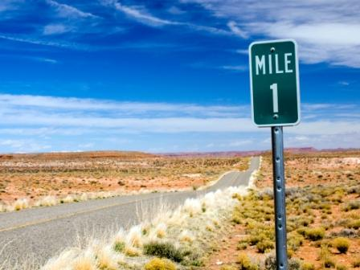

TRAFFIC BREAK: Traffic breaks consist of a single officer and sometimes two (or more) officers collaborating their efforts to clear travel lanes of obstructions, debris, and/or vehicles that have become disabled. To someone who has never witnessed this before, it can be disconcerting. Typically, one officer is on scene with the debris or disabled vehicle and the other will place their patrol vehicle at an angle in the traffic lane hold motorists at a safe distance and speed allowing the assisting officer to clear the travel lane.

It is ILLEGAL to pass a law enforcement officer when this is taking place. When an officer performs a traffic break, this is for the safety of the driving public AND the officers trying to clear the obstruction ahead of you.

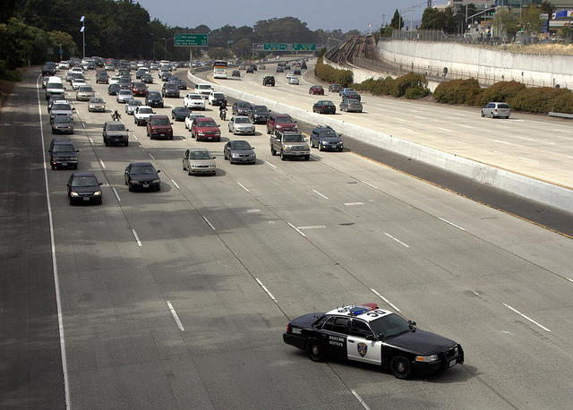
_____________________________________________________________________________________

QUICK REFERENCE GUIDE FOR HELPFUL REPORTING:

LOCATION: What highway or state route are you on? What mile-marker or exit are you near or have just passed?

DIRECTIONALS: What direction of travel are you going or is the vehicle/obstruction going?
EXAMPLE: I-15 NORTH BOUND PASSING MILEMARKER 17 or, US-95 SOUTH BOUND PASSING RAINBOW, or SR-160 EASTBOUND PASSING MILEMARKER 12 IN NYE COUNTY

REPORTING VEHICLES: what is the color, make, model and license plate? What are they doing?

REPORTING OBSTRUCTIONS: What is the obstruction? What lane is it in if you are counting from the very left lane as one?

